Assignment4 – Multi-Period Asset Pricing

ChanJung Kim

November 21, 2018

Part 1: Hansen-Jagannathan Bound

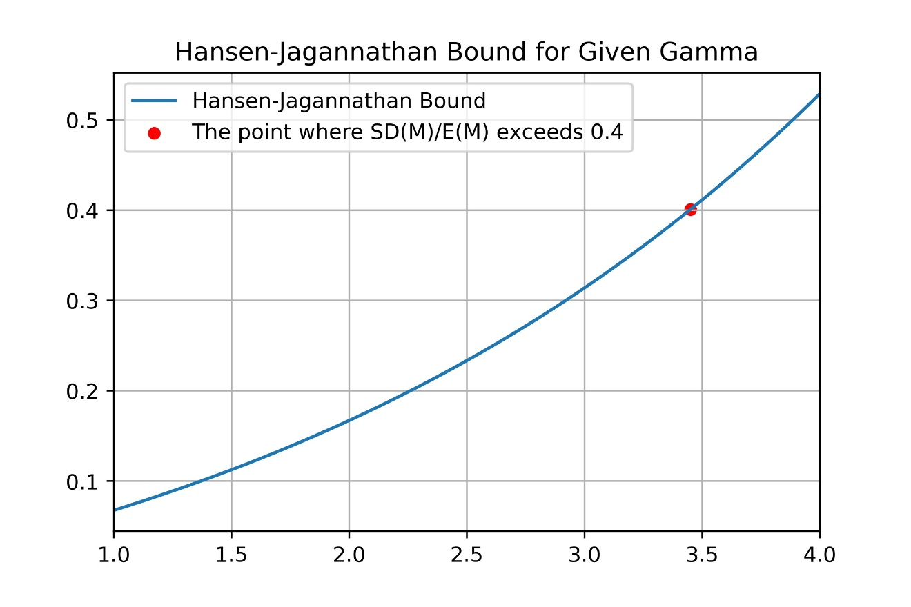

Hansen-Jagannathan bound means that the ratio of the standard deviation of a stochastic discount factor to its mean(SD(M)/E(M)) exceeds the Sharpe Ratio attained by any portfolio. In the simulation result, when the gamma was 3.45 SD(M)/E(M) exceeded 0.4 for the first time. The result implies investors with power utility must have the gamma of 3.45 or above. In a model without rare disaster possibility (nu, ν), implied level of relative risk aversion, or the gamma is known to be greater than or equal to 20, which is implausibly high. The reason the gamma is in the moderate level in this simulation is that adding disaster term has virtually increased volatility of consumption growth rate. When we apply first-order Taylor series approximation to Hansen-Jagannathan bound, the gamma multiplied by the sigma of consumption growth rate (γσc) becomes approximate number of SD(M)/E(M). It means that when the Sharpe Ratio is fixed, the gamma and the sigma are inversely related. Therefore, when rare disasters are supplemented to the model, the gamma drops to the plausible level.

Part 2: Price-Dividend Ratio

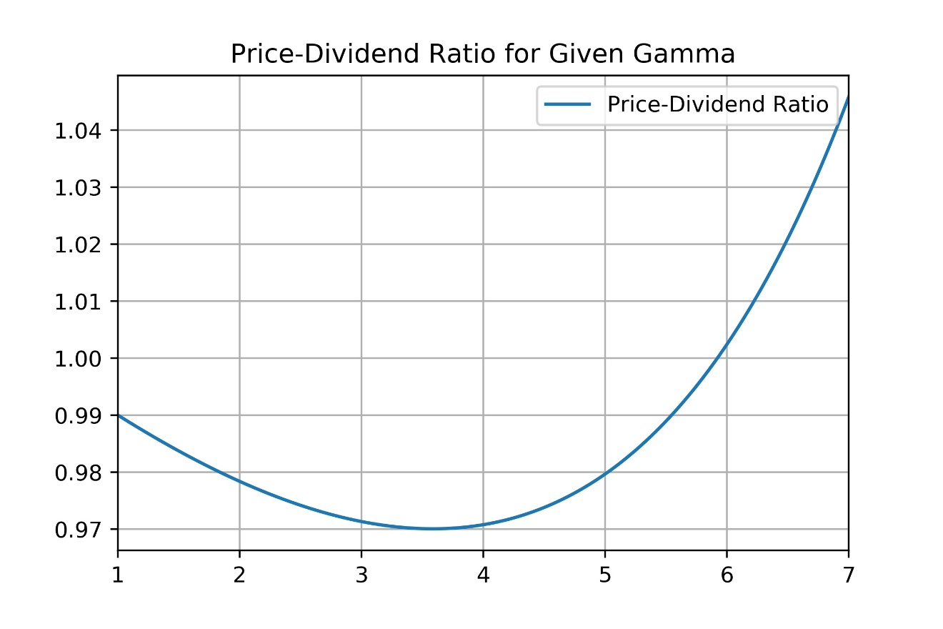

If g̃ is bigger than one, the price-dividend ratio should be strictly decreasing function as the gamma increases. In this simulation, however, the price-dividend ratio decreases to somewhere between three and four and starts to increase after that point. The change in the direction of the slope is also due to the rare disasters. In case disasters happen, the market’s aggregate consumption falls drastically, sending g̃ to far below one. When the gamma stays below the point of inflection, the gamma is not big enough to amplify those below-one-g̃ values to offset usual g̃s without disasters. On the other hand, when gamma is greater than a certain number, the amplified rarely happening below-one-g̃ values begins to overwhelm the usual g̃ values, changing the direction of the curve.

Part 3: Equity Premium

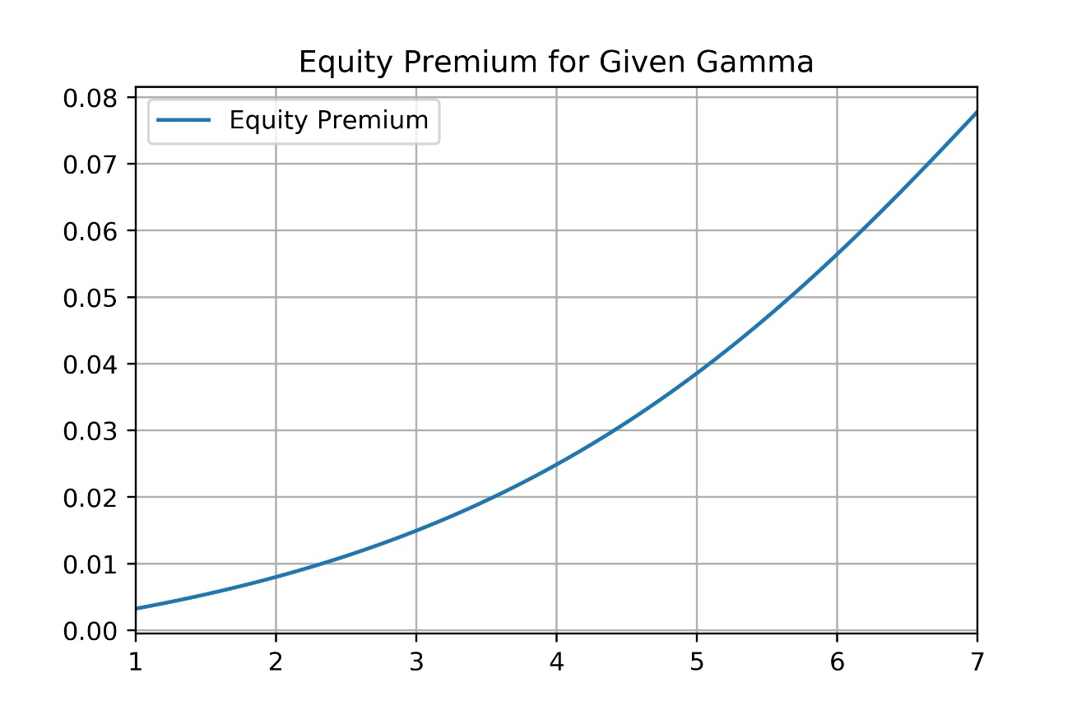

According to the simulation result, equity premium and the gamma have a positive relationship. This result is straightforward in a sense that investors with higher relative risk aversion would require greater risk premium for the risk they bear.